## By Austin Zhang Yi, Tham Jun Quan, Thomas Jiang

## Introduction

A common machine learning problem would be to classify specific activities performed by human subjects. This project seeks to go a step further and classify both the activity and the subject performing the activity.

Using the T,P,E framework, the problem can be summarized into:

* **Task** - Predict the activity *and* the person performing the activity
* **Performance** - Percentage of actions *and* person performing the activity correctly classified
* **Experience** - PAMAP2 data set of labeled IMU readings available from the UCI Machine Learning Repository

**Objective**

The objective of our project is to evaluate empirically the performance of various machine learning algorithms in terms of the time taken to train the model, accuracy, precision and recall. Our project also aims to empirically evaluate the performance of methodology used to predict both the activity and subject. We will be using Gaussian Naive Bayes and Support Vector Machines in this project. The reasons for these choices will be explained below.

**Methodology**

Detailed exploration will be done to understand the data set in terms of the distribution of data and the component that explain the most variance. 3 different model construction approaches will then be compared in the classification of human activity and the person performing it. The 3 model construction methods that will be compared are summarised as follows:

1. Classify Subject (Person) --> Feed subject back into model to classify action of the subject
2. Classify Action --> Feed action back into model to the classify subject
3. Classify both subject and action simultaneously

The model will be selected based on accuracy, precision and recall as well as the computational complexity of training the model. Computational complexity is often an important factor in deploying a model. Supervised learning methods will explored and used to construct the model. The model will then be interpreted to extract insights on how are the actions and subjects classified. Hold-out and k-fold cross validations were used for model validation. Github was used for source control.

## 

## About the Data Set

The PAMAP2 data set available from UCI Machine Learning Repository [(Link)](https://archive.ics.uci.edu/ml/datasets/PAMAP2+Physical+Activity+Monitoring) consists of data collected from 9 human subjects. Each subject performed 18 different physical activities in a controlled environment and in the exact same sequence of activities, 7 of which were optional activities. These 7 activities were considered out of the scope of this project. The activities performed by each subject is summarized into the table below.

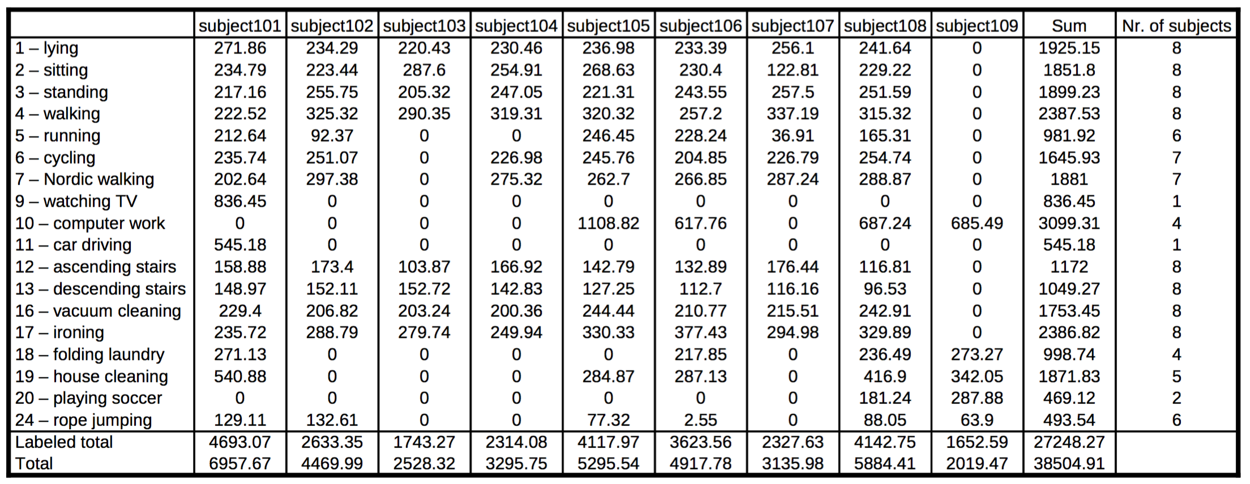

The 11 activities in scope for this projects were: * Lying * Sitting * Standing * Ironing * Vacuuming * Walking upstairs * Walking downstairs * Normal walk * Nordic walk * Cycling * Running.

The data were collected via a heart rate monitor and 3 Colibri wireless inertial measurement units (IMUs) attached to each subject's body: one over the wrist, one on the chest and one on ankle. The heart rate monitor has sampling rate of 9Hz and each IMU generates data that is split over 17 columns with self-explanatory labels.

## Data Preparation

As the data set exists in 9 separate .dat files, a script was prepared to read the data and consolidate it into one .txt file for easier processing. Activities that are performed by less than 6 subjects and activities performed for only a few seconds (i.e 24 - Rope Jumping) were removed. Optional activities reside in separate data files and are not read. Each of the records was also labeled with the subject performing the activity as part of the initial and consolidated data.

**Missing Values** - The missing values were either caused by the lost of signals or the different frequencies the monitors record the data. As such, missing values are populated with the last valid value for the subject and if there is no valid value before, the first valid value after the record was used. This was done for each subject's data.

**Invalid Data** - Orientation is not valid in this data set as stated in the code book and was removed. Accelerometer data for with the scale of ±6g was also removed from the data set as recommended by the code book as readings are saturated for high impact movements such as running.

**Derived Subject-Activity** - An additional variable was created to concatenate subject and activity such that subject-activity is made up of 5 digits with the formula (100 * subject) + activity. For example a person with subject 101 performing activity 12 will be derived as (100*101) + 12 = 10112. After data cleansing and preparation, the total records used for training and testing the model is 1,893,511.

## Data Exploration

### 

### Univariate Exploration

We explore the properties of each feature to observe for any special trends. We do so by observing the distributions of each variable.

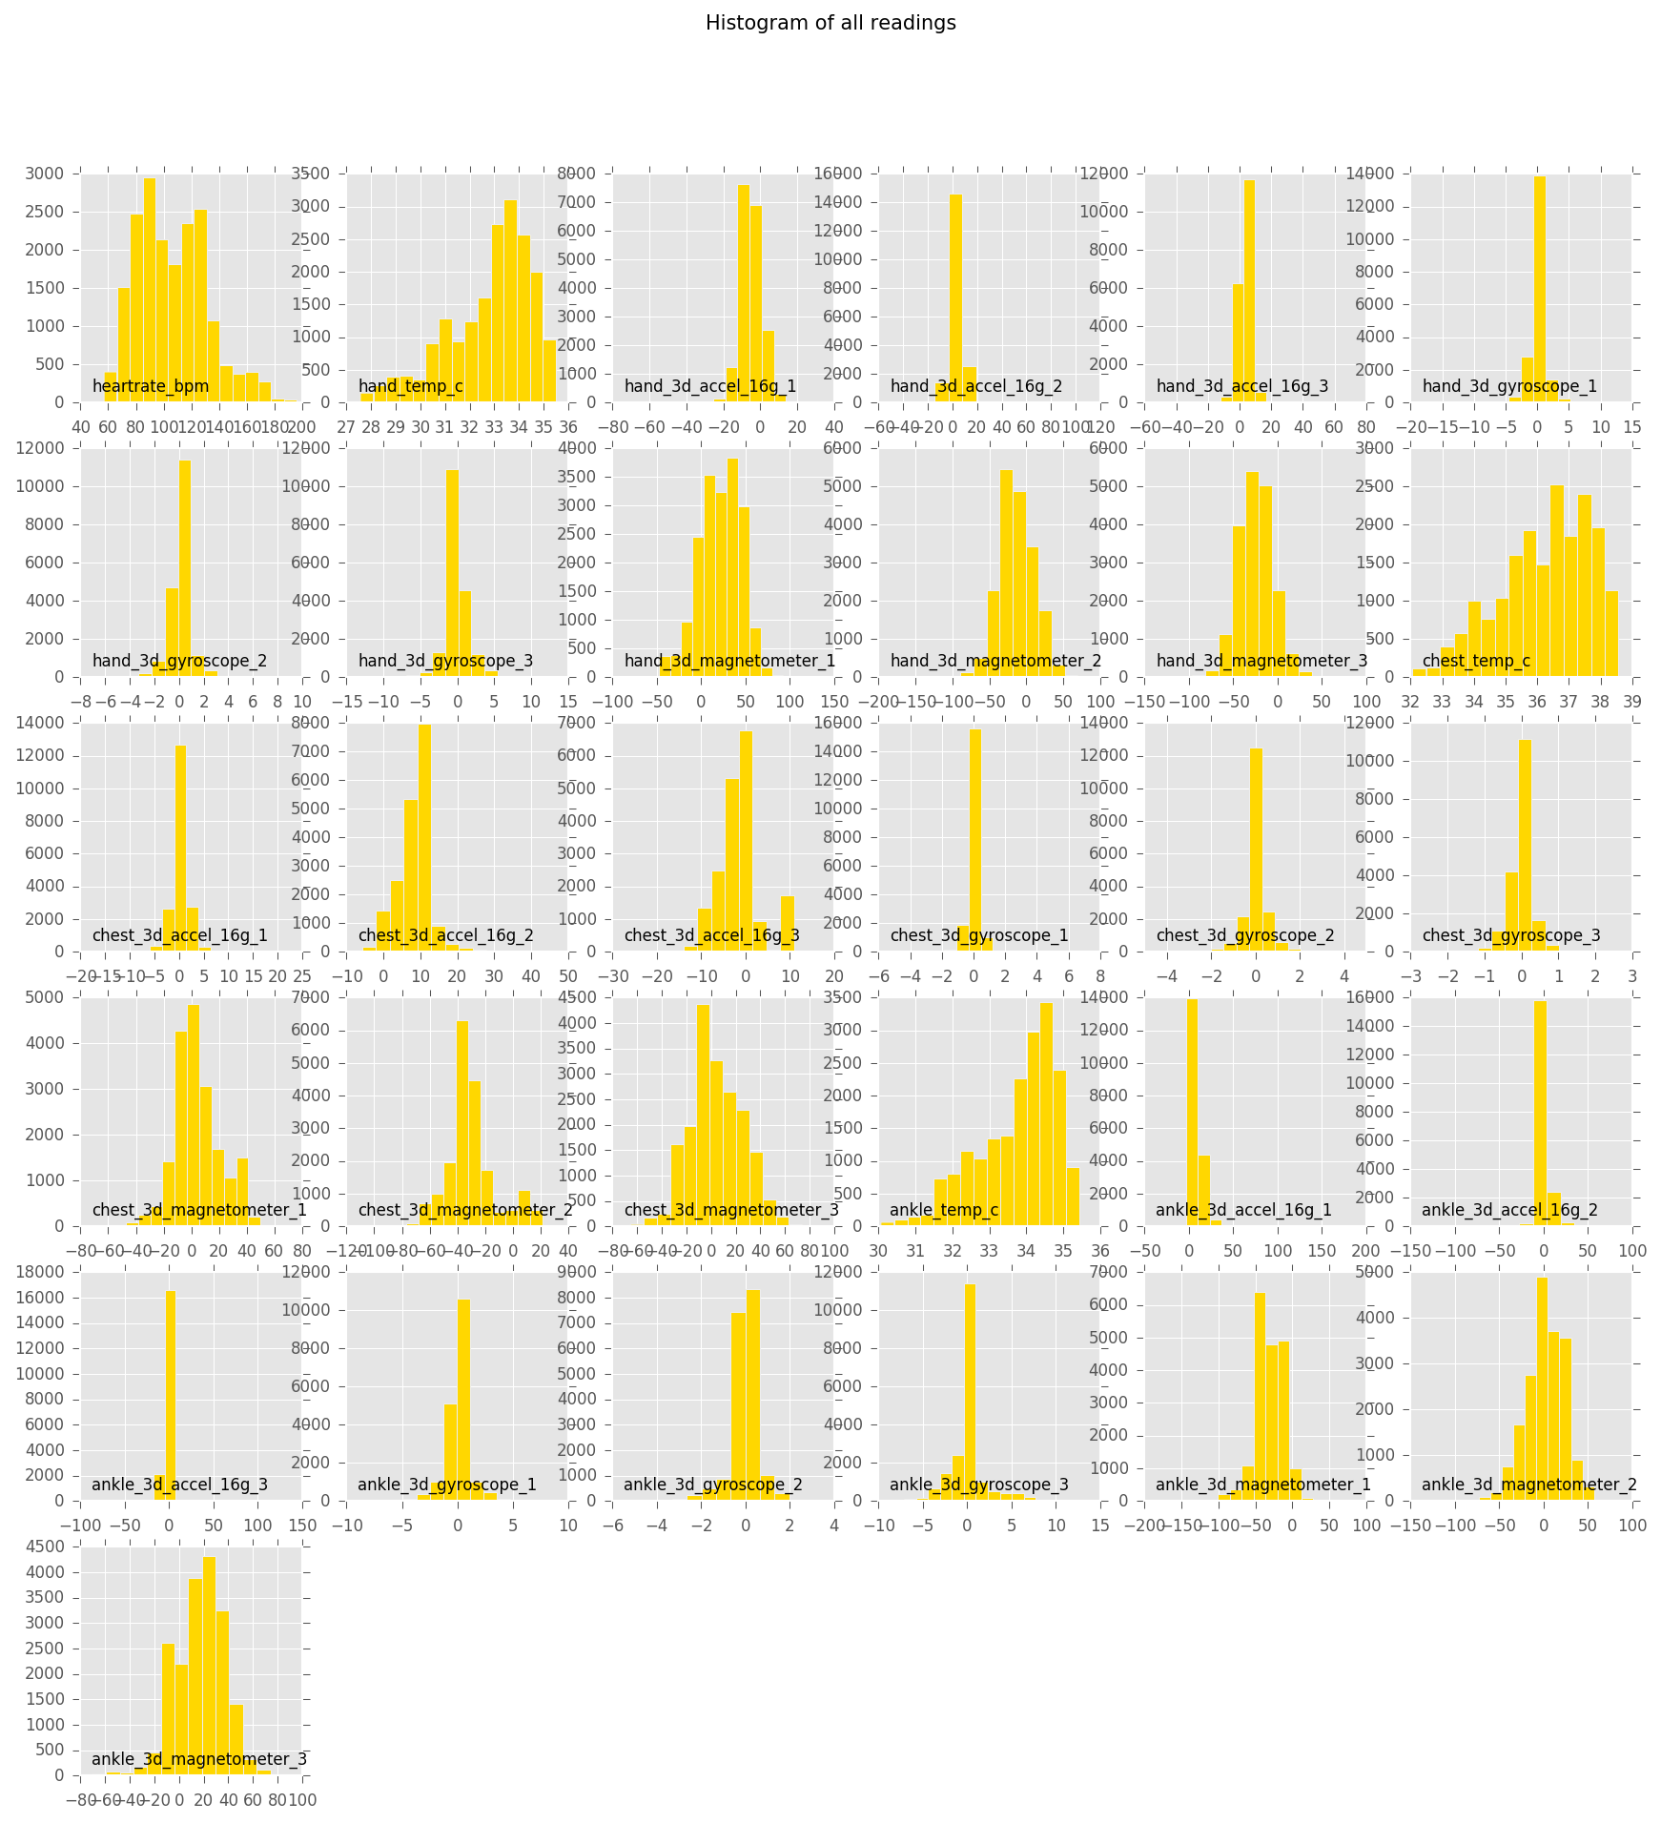

It can be observed that the heartrate_bpm, and temperature readings such as hand_temp_c, chest_temp_c and ankle_temp_c, and the magnetometer readings have a greater variance in their distributions as compared to the accelerometer and gyroscopic readings. As a rule of thumb, we would expect the variables with more variance to have a greater impact on the predictive power of the model.

It is also interesting to observe that hand_temp_c, chest_temp_c and ankle_temp_c have very similar distributions which are slightly left-skewed. On the other hand, heartrate_bpm has a slightly right-skewed distribution. We can expect that the temperature readings and heartrate_bpm to have opposing effects.

### Bivariate Exploration

Next, we look into the pair-wise correlations between the variables to look out for any strong correlations which may affect the construction of the model. For easier visualisation, we plot a pair-wise correlation plot.

**Pair-wise Correlation Plot**

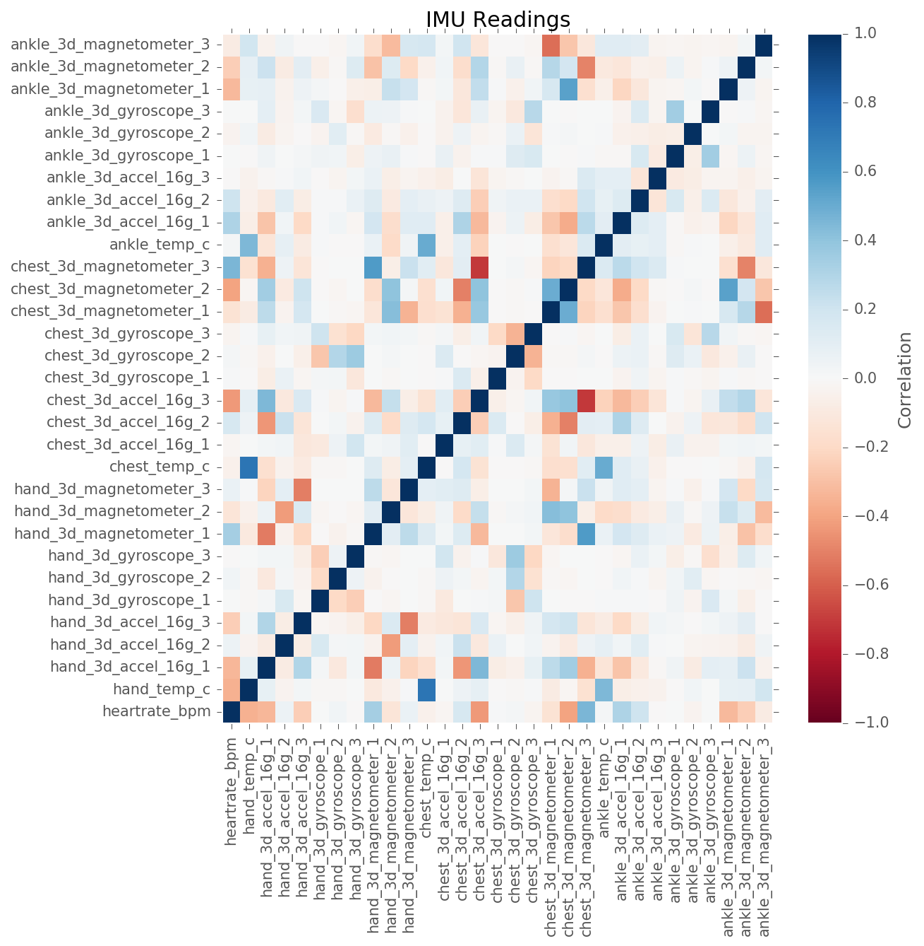

The correlation shows a strong correlations between several variables, some of which are:

* chest_temp_c and hand_temp_c
* chest_3d_magnetometer and chest_3d_accel
* ankle_3d_magnetometer and chest_3d_magnetometer

The correlations between several of these variables are relatively strong (around 0.5 and above). On the other hand, we can also see that most of the variables are not very strongly correlated with each other. This goes to show that each variable could each contribute to the prediction of the model. However, when relating back to the univariate exploration, we would not expect many of these variables to have strong effects on the predictions due to the lack of variance in their distributions.

### Principal Component Analysis (PCA)

Given the number of features, we thought it would be important to conduct a PCA to observe for any further interesting properties about the dataset. PCA was conducted on the dataset to reduce dimensionality and the 2 variables subject and activity_id were concatenated into one target variable subj_activity for easier visualisation.

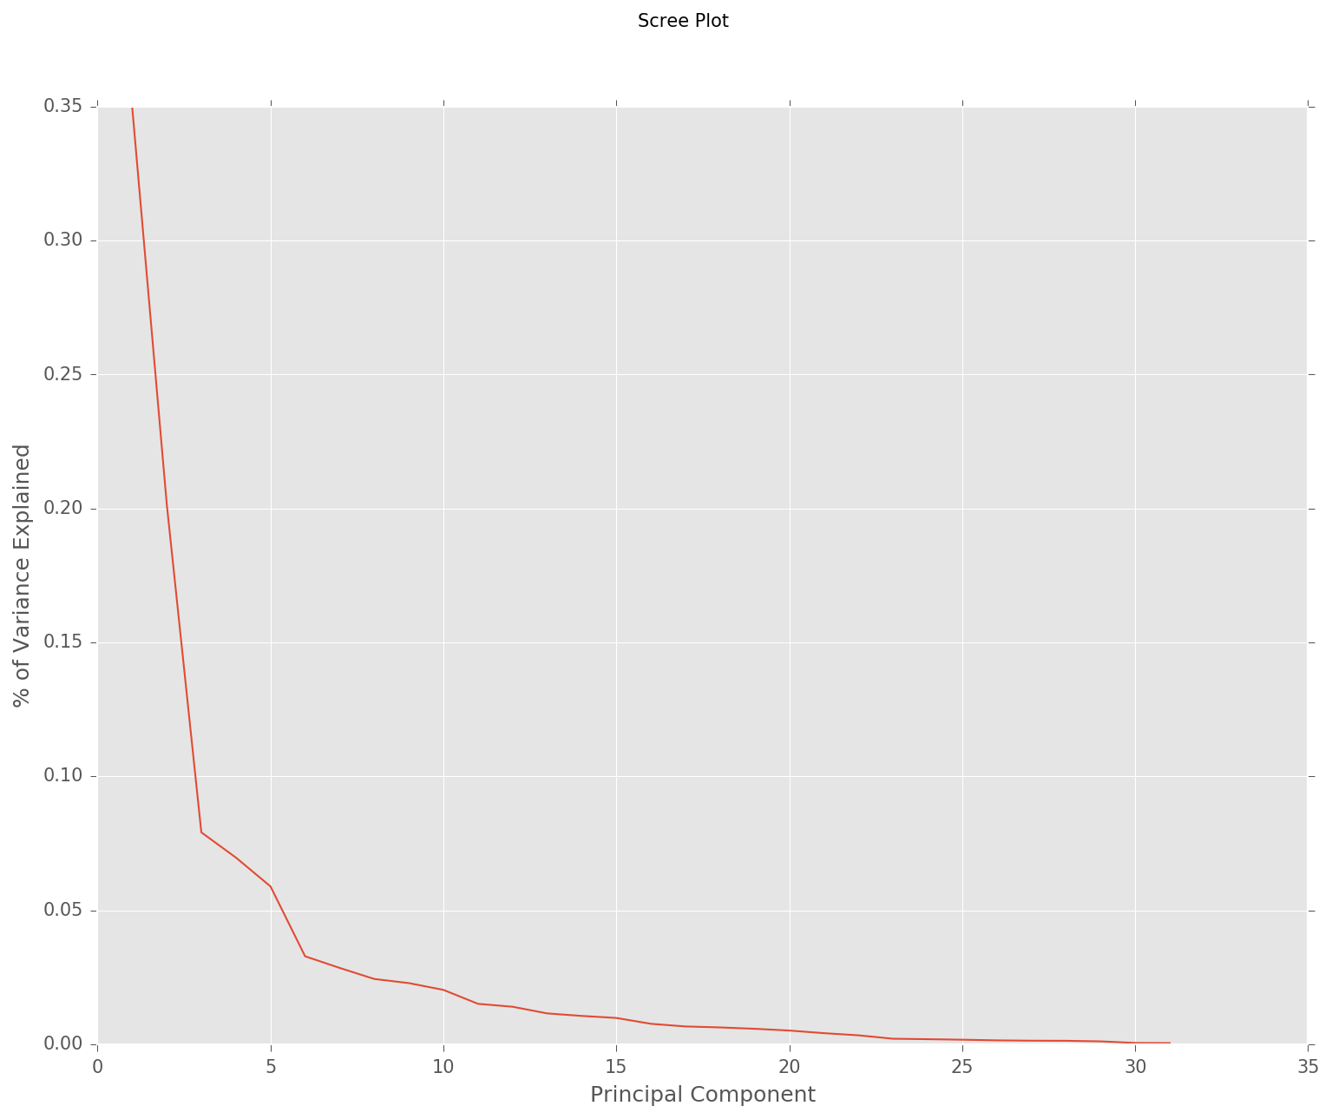

We can see from the Scree Plot that most of the variance can be explained by the first 3 components as there is a sharp kink in the Scree curve around that point.

The top 3 principal components along with their correlation with the original variables are shown in the table below.

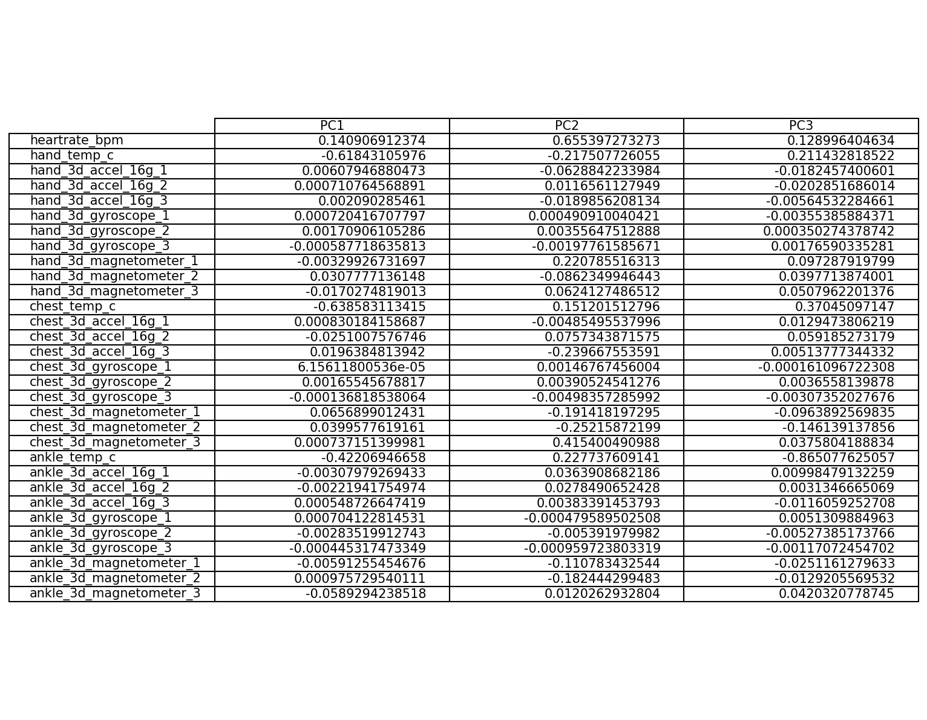

**First Principal Component (PC1)** - We can see that PC1 has the strongest correlations with chest_temp_c (negative), hand_temp_c (negative), and ankle_temp_c (negative). This is not surprising as we relate this back to our univariate analysis in that the 3 variables had high degrees of variance. Also, their distributions were similar - explaining the negativity of the correlations with PC1. Also, it is interesting to note that heartrate_bpm has a positive correlation with PC1, but to a smaller degree when compared to the temperature variables. This can be explained by the opposing skews in their distributions. It is expected that heartrate_bpm and the temperature variables have opposing correlations. We can conclude that PC1 is characterised and affected strongly by temperatures of different body parts of each subject.

**Second Principal Component (PC2) -** Interestingly, heartrate_bpm has the strongest correlation with PC2 out of all the variables. Other variables that have considerable correlation with PC2 are the magnetometer readings from the hand and chest, with chest having a higher correlation than that of the hand. Magnetometers measure to magnetism around the area where they are attached to. In this case, both heartrate_bpm and chest_3d_magnetometer had positive correlations with PC2. With more movement and activity, comes stronger noise and readings measured by the magnetometer attached onto the chest. Also, we can observe that the 3 temperature variables have positive correlations with PC2, hinting that they, along with heart rate, will cause an increase in PC2 when they have higher readings. Consequently, we would also expect higher heart rates. As such, PC2 seems to be explained mostly by the amount of activity the chest and the heart are engaged in, and we can expect both of them to be closely related. This will be bolstered by the fact that greater activity in the human body will generate more heat, causing an overall increase in body temperature. At this point, we can take a look at the interactions between PC1 and PC2, coloured by subj_activity.

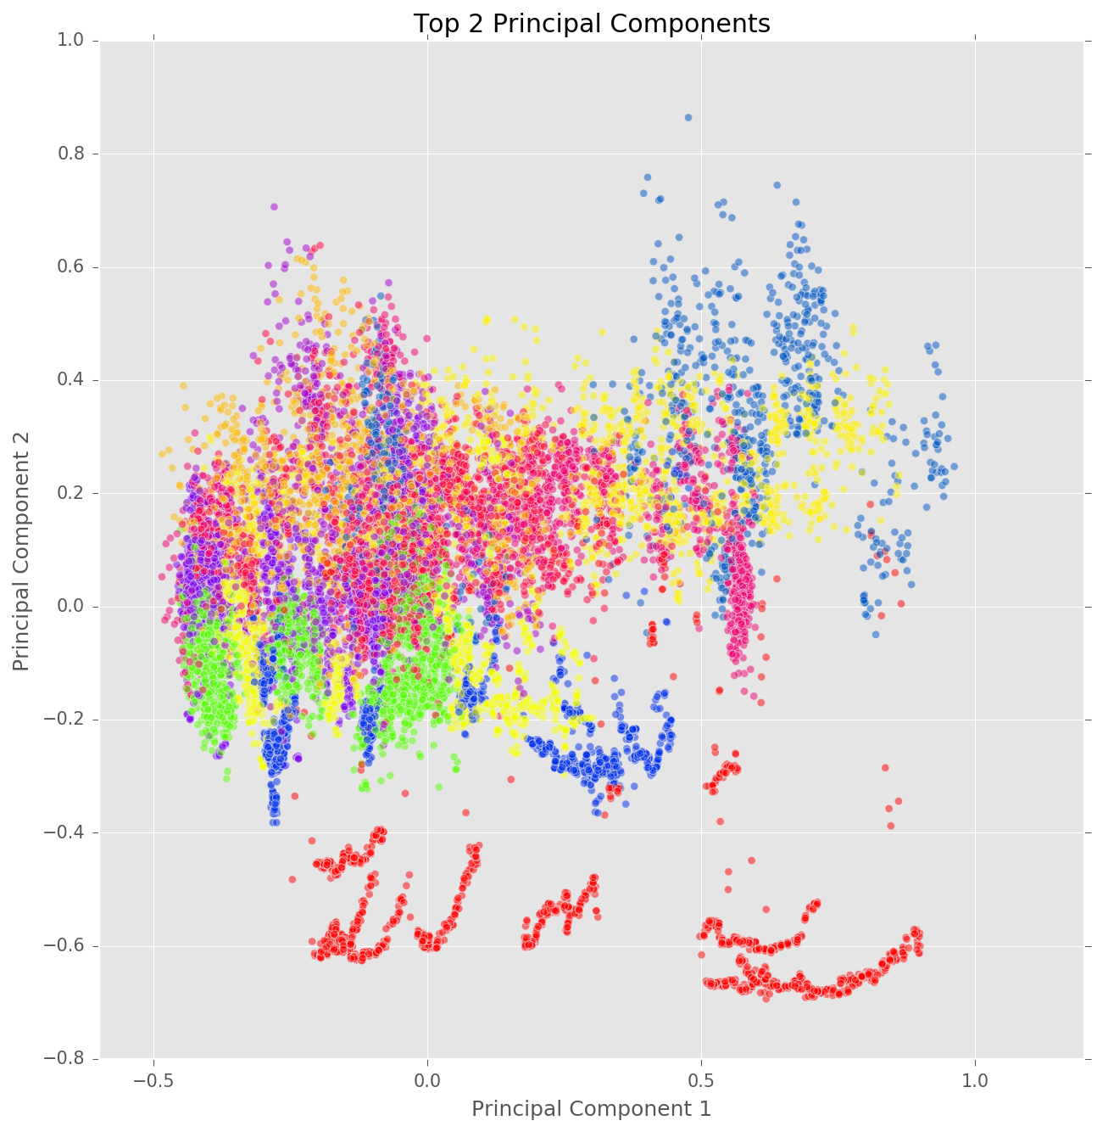

We can see that there is a high degree of overlap between different levels of subj_activity with some obvious outliers which seemingly form their own cluster based on visual observation. We continue to analyze PC3 to see its impact on the data.

**Third Principal Component (PC3)**

In this PC, ankle_temp_c has the strongest correlation of around -0.865. The next variable in line would be hand_temp_c with only 0.211 correlation with PC3. Closer inspection into the PC reveals that ankle_temp_c dominates this PC. We take a look at its effect when a plot is generated with PC1 and PC2.

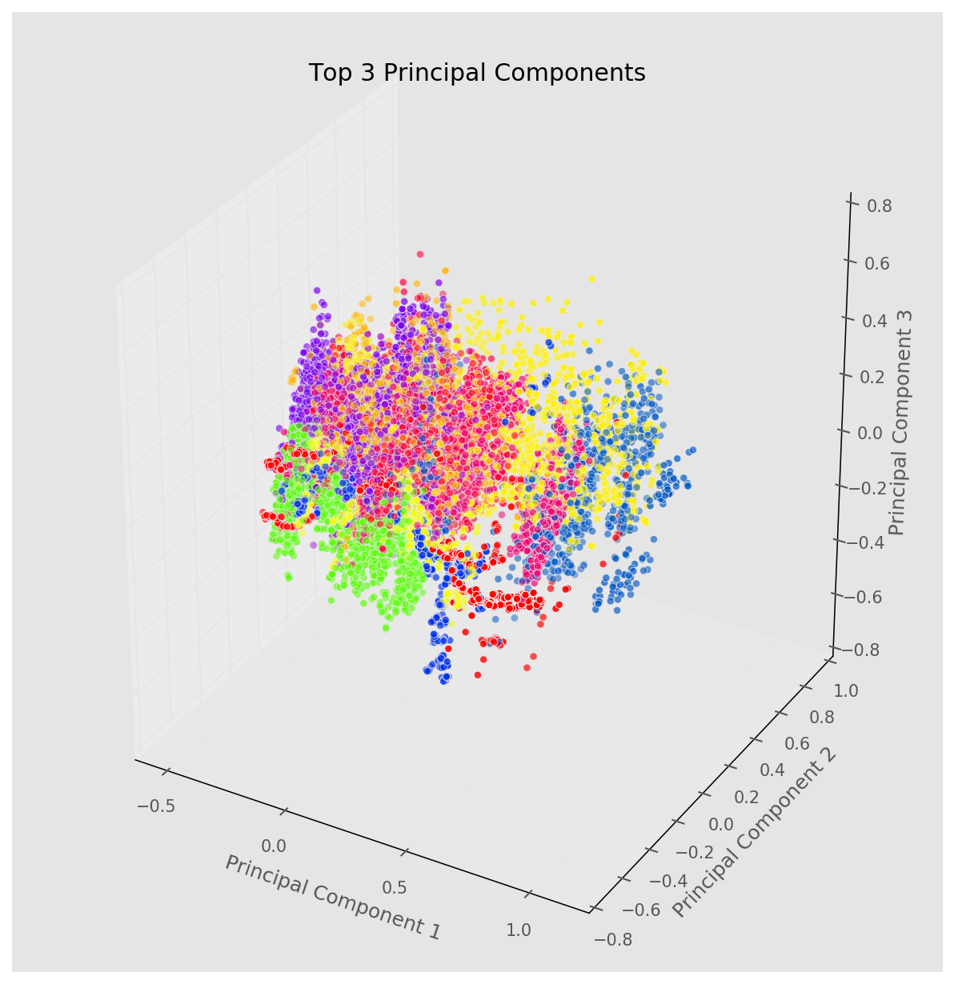

We can see that the number of obvious outliers has decreased drastically with the inclusion of PC3. PC3, characterised by its inverse relationship with the ankle temperature, seemingly 'brought in' the outliers.

After analysing the principal components, we are now ready to create and compare our models.

## Model Comparison

Given the classification problems and methodologies. We used several models to classify the data set. In choosing the best model, we applied the following criteria:

* **Accuracy**: Number of correctly predicted classes over total number of actual classes.
* **Computational Complexity**: The amount of time taken, or estimated amount of time taken if not successfully run, was used as a proxy.

The classifiers used were the following:

* SVM with Stochastic Gradient Descent (SGD)
* Gaussian Naive Bayes
* Multi-output Classifier using the best model from initial comparison

The approach taken can be generalized as such, based on the methodology above:

1. Split data using Stratified Shuffle Split
2. Perform PCA to reduce dimensionality (optional)
3. Train model
4. Predict
5. Output training duration and scores
6. Output test scores
7. Repeat for 3 model construction methods:
   * Subject -> Activity (S -> A)
   * Activity -> Subject (A -> S)
   * Both

All results are output in result folder in the file result_final.txt. Models were ran on 2 machines.

1. Machine A - 4GHz Intel Core i7, 16GB RAM

2. Machine B - 2.53 GHz Intel Core 2 Duo, 8GB RAM

All durations were taken from Machine A, unless otherwise stated.

#### Support Vector Machines

Due to the large sample size, SVM using SGD learning was our first model. Being an efficient model, runtime would be fast and we would get a quick feel of how the model performed. Note that PCA was not carried out in this case. It has been proven that RBF kernel is not suitable in cases where the number of features is large - a linear kernel would be more suitable[1]. SVM without using SGD with a linear kernel was also ran to have a gauge of the time needed to train the model.

Fitting the model took upwards of 5 hours on Machine A and did not complete successfully.

SVM using SGD algorithm were first ran at a fixed alpha of 0.1 to get a benchmark. The models were trained for a 100 times each due to the fact that SGD may encounter a local minima. The mean, maximum and minimum accuracy scores are shown for each of the methods are shown below.

|  |  |  |  |  |
| --- | --- | --- | --- | --- |
| Method | Accuracy (mean) | Accuracy (max) | Accuracy (min) | Average Time Taken (seconds) |
| S -> A | 0.48 | 0.44 | 0.52 | (S+A) 11.11 + 14.54 = 25.65 |
| A -> S | 0.48 | 0.43 | 0.53 | (A+S) 15.19, 11.28 = 26.47 |
| Both | 0.63 | 0.58 | 0.67 | 113.79 |

Training the model to predict both at the same time was significantly slower than training to predict subject then activity or vice versa. This is due to the additional number of classes (different subject-activity combination). It is also worth noting that on Machine B, using the method “Both”, training the model took 238 seconds on average.

We can see that predicting both targets together produced best results. We took this further and used Grid Search Cross Validation was used to find the level of smoothing that produced the best results under the 'Both' condition.

The model was trained for 60 times as we now have a sense of the accuracy of the model from above. Furthermore, a 2-fold cross validation was done during training. The mean, maximum and minimum accuracy scores are shown for each of the methods are shown below.

|  |  |  |  |  |
| --- | --- | --- | --- | --- |
| Method | Accuracy (mean) | Accuracy (max) | Accuracy (min) | Average Time Taken (seconds) |
| Both | 0.63 | 0.49 | 0.68 | 621.75 |

The best model selected from the Grid Search produced an accuracy of **0.68** at alpha = 0.1, which took **621.75** seconds to train. Training time include training with the various parameters provided to Grid Search. The parameters are {'loss':['hinge'],'alpha':[0.0001,0.001,0.01,0.1,1]}

The lengthy time taken to train the model was primarily due to cross-validation and training with the different alphas.

#### Gaussian Naive Bayes

The Gaussian Naive Bayes is a generative model that is based on very simplistic calculations to calculate posterior probability. As such, it would be very efficient, even on large datasets. Further, it is well-known that Gaussian Naive Bayes has been performant in real-world situations despite its unrealistic assumption of conditional independence. Therefore, we next used Gaussian Naive Bayes with scaling and PCA. The choice to scale prior to conducting PCA was because the variables were measured on different scales (e.g. Heartrate in beats per minute vs. Chest temperature in Celsius). Also, scaling before PCA has been shown to produce better results[2].

|  |  |  |
| --- | --- | --- |
| Method | Accuracy | Time Taken (seconds) |
| S -> A | 0.4 | 0.5 + 0.52 |
| A -> S | 0.5 | 0.52 + 0.48 |
| Both | 0.64 | 0.74 |

The efficiency of the model is evident in the time taken to train and test the model. It is more than 10 times faster than the SVM model in the S -> A and A -> S conditions and over 100 times faster under the 'Both' condition. Interestingly, Gaussian Naive Bayes does not necessarily outperform the tuned SVM model with SGD. However when we account for the efficiency of the model, it puts Gaussian Naive Bayes slightly ahead as its accuracy is almost on par to that of the SVM model.

However, it is also important to note that Gaussian Naive Bayes is considered relatively immune to the 'Curse of Dimensionality'. This is largely due to its simplicity. Given this, it would be interesting to observe the model's performance using all dimensions in the original data, without PCA. As such, we ran Gaussian Naive Bayes model again, but without PCA. Both subject and activity were predicted at the same time as it is the best method.

|  |  |  |
| --- | --- | --- |
| Method | Accuracy | Time Taken (seconds) |
| Both | 0.96 | 1.48 |

The model under the 'Both' condition produced an accuracy of 0.96 with a slight drop in efficiency compared to its counterpart with PCA, presumably due to the increase in number of features used for training. The decrease in efficiency is not significant when compared to the increase in accuracy. This disproportionate trade-off in favour of accuracy has made this model an attractive one for our case. Accuracy for training is the same at 0.96 and does not does the presence of overfitting.

As such, we selected this model to be our final model to be compared with a multi-output classifier shipped with sklearn.

#### Comparison with Multi-Output Classifier

In this comparison, the main objective is to compare the performance of two algorithms that theoretically aim to do the same thing. The difference is in the details where the 'Both' condition predicts a concatenated target variable, essentially converting the problem into a binary classification problem, while the Multi-output Classifier still considers multiple target variables (in this case 2) and predicts them together. The multi-output classifier classifies by fitting 1 classifier per target. In our case, 1 classifier will be fitted to predict Activity and 1 classifier will be fitted to predict Subject. The result of multi-output is shown below.

|  |  |  |
| --- | --- | --- |
| Method | Accuracy | Time Taken (seconds) |
| Multi-Output | 0.54 | 2.28 |

The Gaussian Naive Bayes model with Multi-output Classifier produced an accuracy of **0.54** which took a duration of **2.28** seconds. This is significantly less performant than the standard classifier in terms of accuracy and duration.

The difference in performance could simply be the difference between the strategy adopted by the Multi-Output Classifier.

#### K-fold Cross Validation

The k-fold cross validation was also performed to evaluate the Gaussian Naive Bayes model in addition to the hold-out method used earlier. k-fold was used in addition to the hold-out method due to the fact that with k-fold, the evaluation of the model is less impacted by how the data is divided. StratifiedKFold from sklearn was used due to the unbalanced classes we are trying to predict.

10-fold cross validation was used and the average accuracy of the Gaussian Naive Bayes model predicting both Subject and Activity at the same time is:

The average accuracy of the Gaussian Naive Bayes model predicting both subject and activity at the same time as an average accuracy of **0.9363**. The accuracy does not indicate the presence of overfitting.

#### Visualizing the Classifications

To understand how the Gaussian Naive Bayes classify the data set, the principal components and the temperatures were visualized with the classes predicted.

* Colors denote the various subject - activities
* Circles denote correctly predicted classes
* Inverted triangles denote incorrectly predicted classes

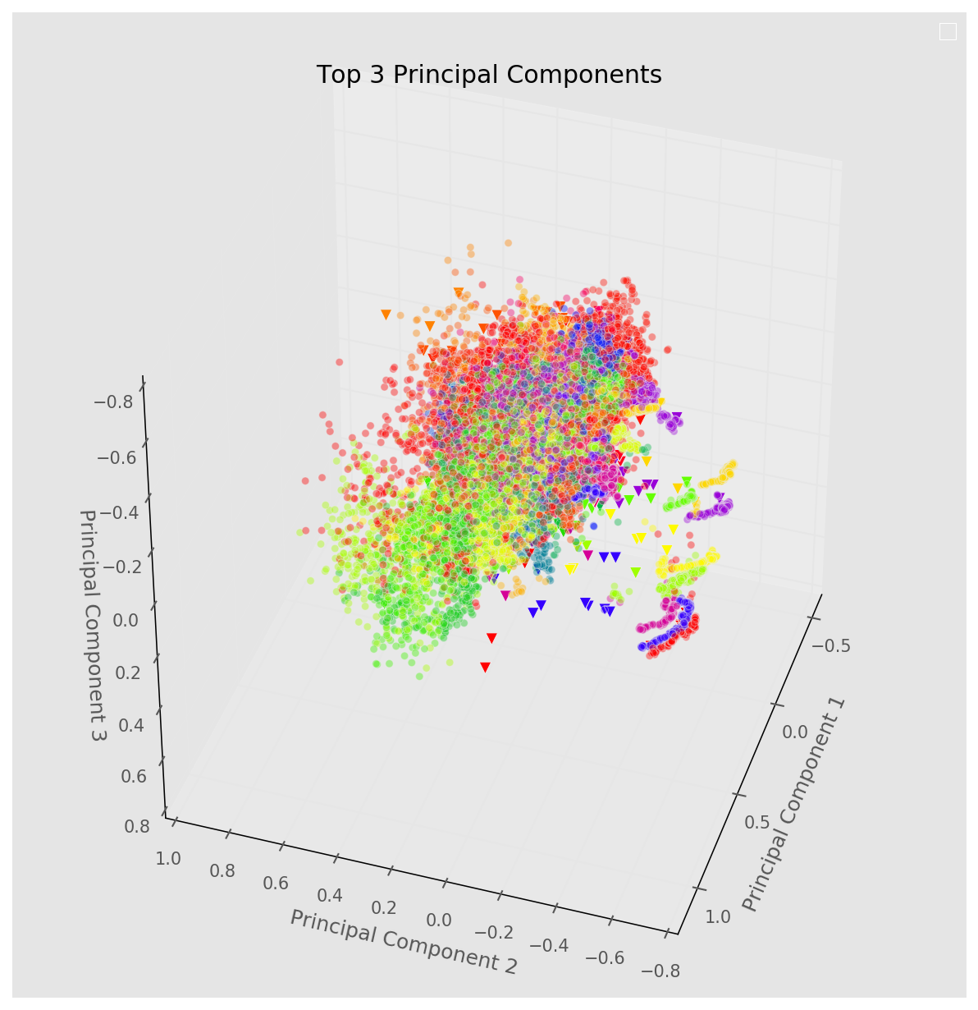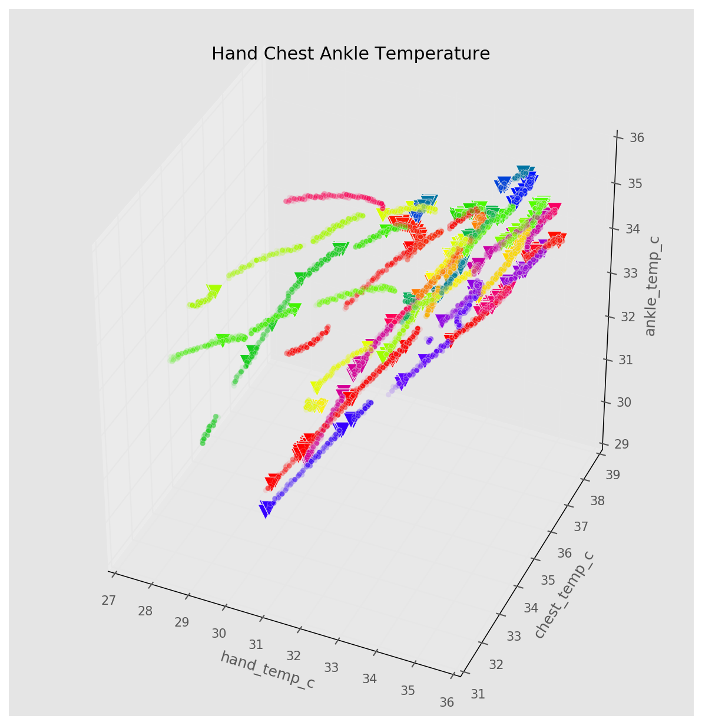

It seems that the classifier was quite good at predicting the points that are close together (shown in the PCA plot). Similar observations were made in the Hand Chest Ankle Temperature plot. Next we look at how well the classifier perform in classifying the subjects, activities and both subject-activity.

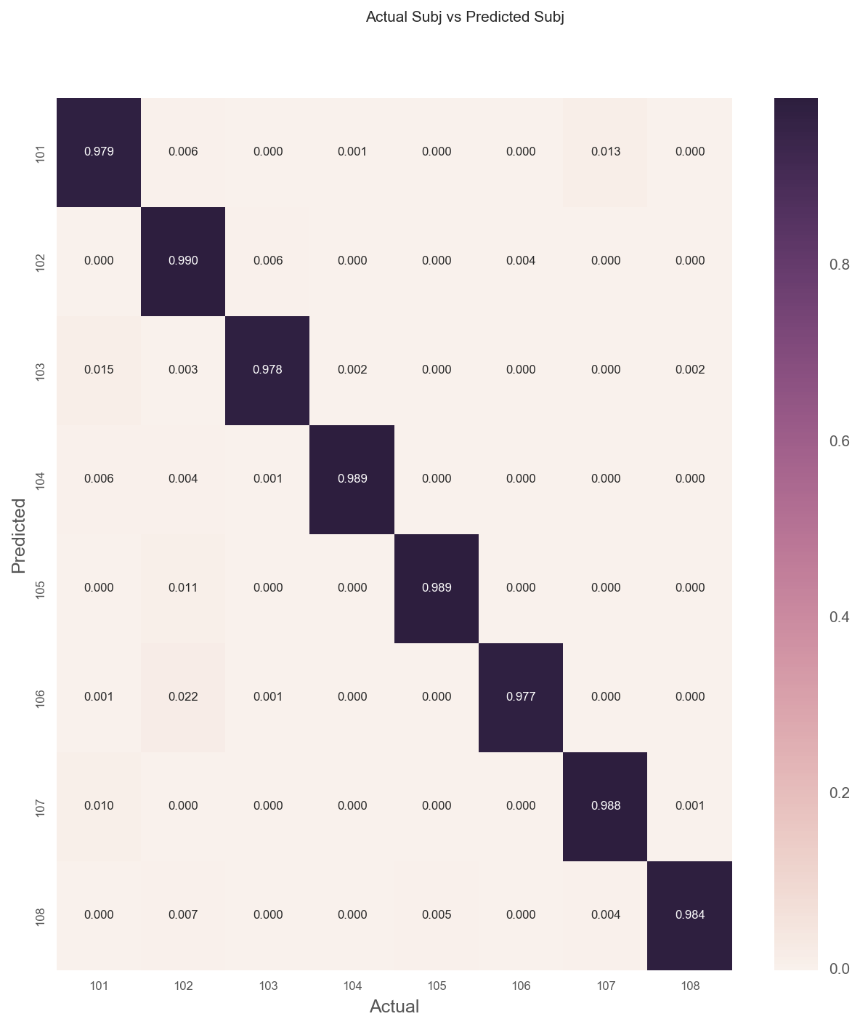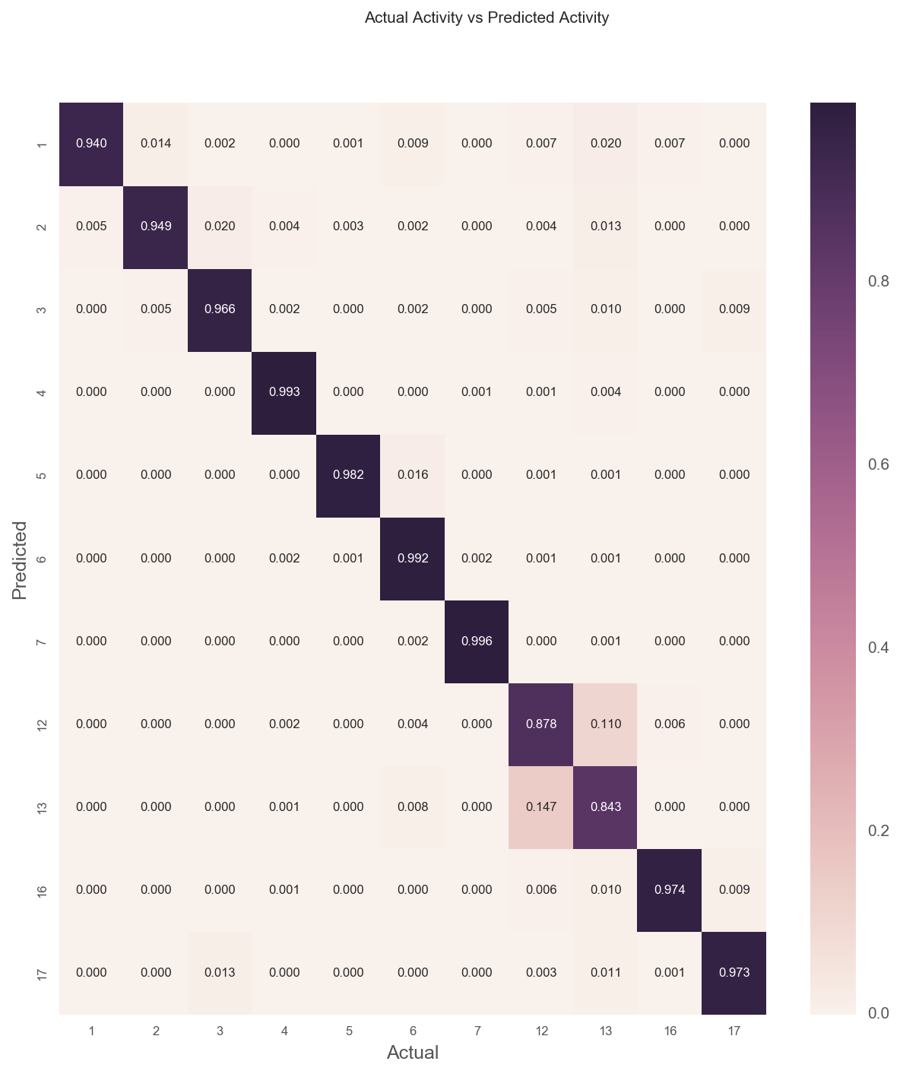

It seems that the classifier has problems classifying activities 12 and 13 which corresponds to Ascending Stairs and Descending Stairs. We can imagine these 2 activities to be quite similar which explains the error in classification. Lastly, we plot the subject-activity classification.

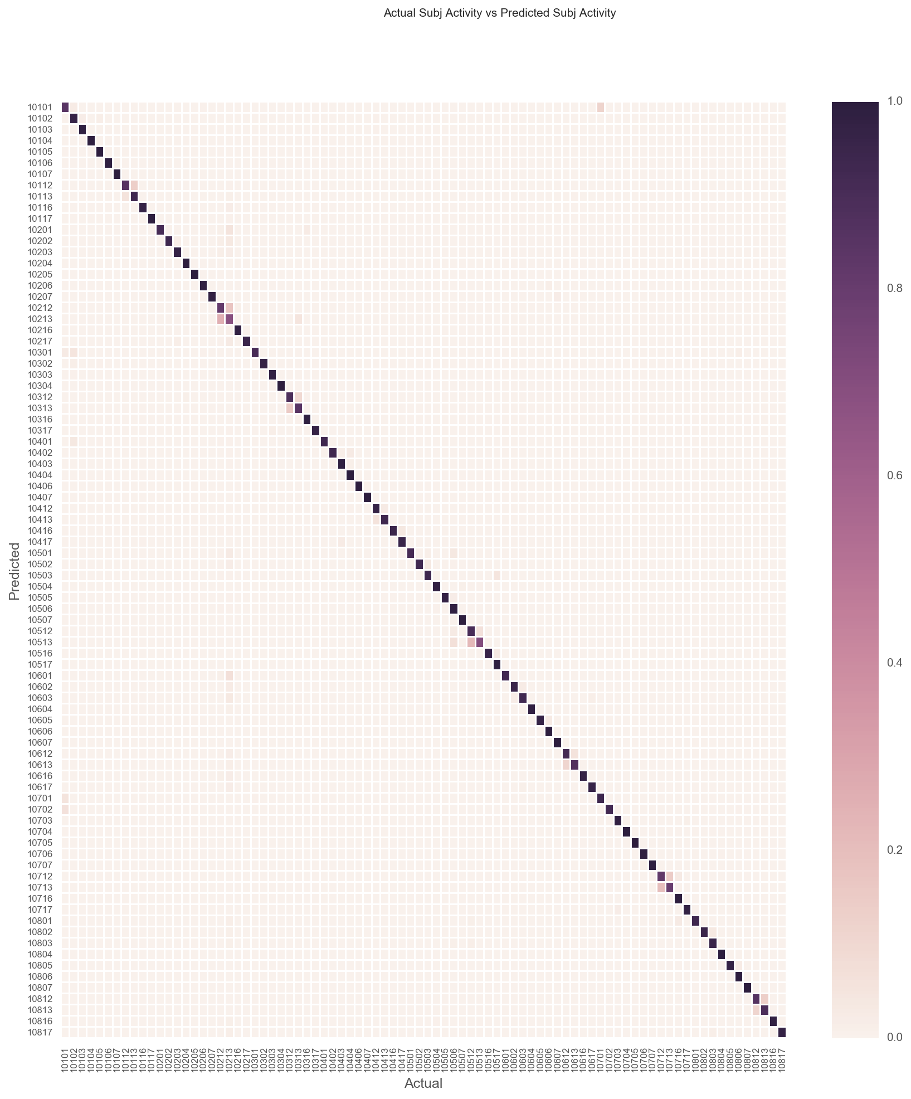

Similarly, we notice that the error tend to be predicting activities 12 and 13.

## 

## Conclusion

Our study has also shown that:

* Gaussian Naive Bayes model without PCA tends to perform better, in terms of both accuracy and efficiency. This is especially so when sample size is large.
* Linear SVM without SGD was very slow to train on this data set.
* SVM with SGD provided a performance boost, but could not compare with Gaussian Naive Bayes in terms of accuracy.
* The selected classifier (Gaussian Naive Bayes) have problems classifying Ascending and Descending Stairs.
* Concatenating the multiple outputs into one target variable with more unique levels performs better than trying to predict the target variables as standalone outputs.
* In the application of machine learning algorithms, different trade offs such as accuracy, time taken to train needs to be considered.

An interesting point to note is that the 'Both' condition consistently performed better than the other two methods across all models. Upon close consideration, this can be said to be an expected result. When predicting one target variable after the other, the errors made in predictions stack up. For example, in the case of S > A, the errors made in first predicting 'subject' would then be carried over to wrongly predict 'activity_id' as 'subject' becomes part of the variable used to predict A.

## References

[1] Hsu, et al (2016), [*A Practical Guide to Support Vector Classification*](http://www.csie.ntu.edu.tw/~cjlin/papers/guide/guide.pdf)

[2] Raschka S. (2014), [*About Feature Scaling and Normalization*](http://sebastianraschka.com/Articles/2014_about_feature_scaling.html)